

**Online Career Portal**

**Date Submited:**

**Submitted To:**

Praveen Nair

Program Director

|  |  |
| --- | --- |
| **Document Title** | Online Career Portal |
| **Issued By** |  |
| **Issue Date** |  |
| **Approved By** |  |

Document Revision History

|  |  |  |
| --- | --- | --- |
| Date | Update Description | Contact Name |
| 31/03/2022 | Initial Draft | Arya |
|  | Initial Draft | Ancia |

# Abstract and Current State

# Business Process Affected

# High Level Scope

# High Level Use Case Diagram



# Functional Requirement

|  |  |
| --- | --- |
| **No** | **Use case** |
| FBR-001 | Candidate Search and Apply for a Job to different recruiter |
| FBR-002 | Recruiter register to the web portal and post different job opening and |



# 5.1. Use Case FBR-001

# Assumptions/Constraints

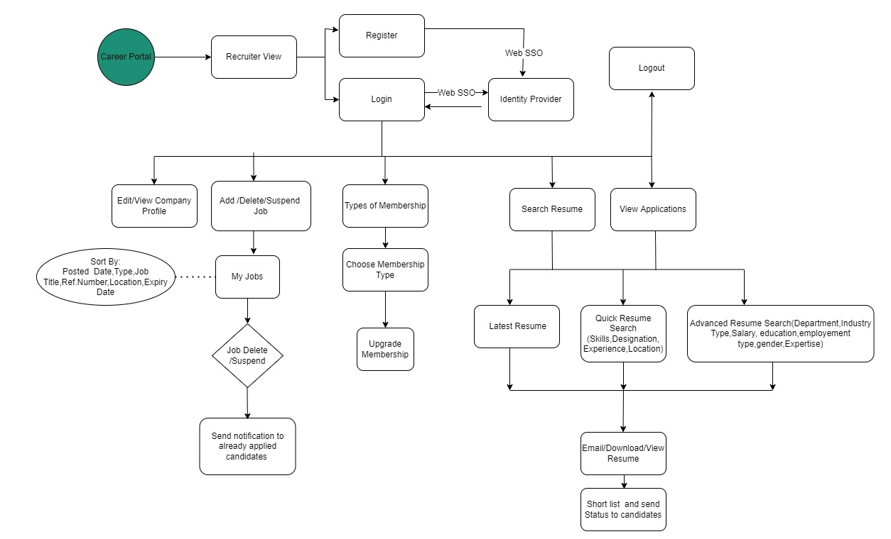

# 5.2. Use Case FBR-002

**Recruiter View**

Recruiter Log into the System

Recruiter Chooses Sign Up to register into the system

Recruiter fill all information about the company

Recruiter fill all the informations

Recruiter fill User Name and Password

Recruiter enter into login page

* Recruiter accesses the website and chooses the register option to become a member; they will be directed to the website's registration page. Recruiter completes all fields, including company name, technical expertise, number of employers, and location. Click the 'Sign Up' button after providing your email address and password.
* If the result is successful, the recruiter will be sent to the login page; otherwise, certain problems may appear, such as
  + Email not match with regExp and show error as Please provide a valid email
  + Password is less than 6 digits, show error: Password must include at least 6 digits time.
  + Any field left blank, show error: All the fields must be filled up.

Recruiter choose Log in to the System

Recruiter Fill user name and Password

Recruiter will enter into the Home page of portal

Recruiter fill all the informations

* Recruiter then goes to the Login page, fills in his or her email address and password, and clicks the Login button. This will take you to the home page of the online career portal.
* If the result is not Successful certain problems may appear such as,
  + Email not match with regExp and show error as Please provide a valid email
  + Password is less than 6 digits, show error: Password must include at least 6 digits time.
  + Any field left blank, show error: All the fields must be filled up.

Recruiter Log into the System

Recruiter update their profile if necessary

Recruiter chooses to add a new job

Recruiter fill all the informations

Recruiter fill all the information about the job

Jobs are listed on the job board

Recruiter delete/suspend a job

All applicants who applied for the job will be notified.

* After logging in recruiters may examine their profile and, if necessary, amend their information by clicking 'Save'.
* Once the recruiter has completed their profile edit, they will be brought to the home page, where they may choose to add a new job, delete an existing job, or keep the job on hold until further notice.
* If a recruiter creates a new job, it will be listed on the job board.
* If a recruiter deletes or suspends a job, all applicants who applied for the job will be notified.

Recruiter log in to the system

Recruiter choose membership tab in home page

Recruiter choose one among the membership plan

Recruiter upgrade the membership for already existing plan

* A recruiter may go to the payment page by clicking on membership on the main page.
* The Recruiter will be able to select from a variety of membership options, as well as upgrade from a current plan.

Recruiter log in to the system

Recruiter search for a job in quick search method

Recruiter advance the search to get refined results

Recruiter view the resume and download/email if necessary

Recruiter make a short list of candidates

Recruiter notify the candidates

The status is reflected in the candidate’s dashboard

* When a recruiter visits the job portal's main page, they may utilize the search option to look for user resumes that are appropriate for their firm/ view all the applications that may receive for their job posting.
* The recruiter does a speedy search to find resumes by defining skills, designation, experience, or location.
* To acquire more focused results, the recruiter will refine the search by specifying Department, Industry Type, Salary, Education, Employment Type, Gender, and Expertise.
* After receiving the narrowed searches, the recruiter will do the following steps.
  + Evaluate applicant resumes
  + Email resumes to their professional email addresses
  + Save resumes locally
* Shortlisted candidates will be notified by the recruiter after the resumes have been evaluated. In the user dashboard, this status will be reflected.

Admin View

Admin log into the system

Recruiter fill all the informations

Admin choose add a new admin

Recruiter fill all the informations

Admin fill the credential and assign to new admin

Recruiter fill all the informations

Admin choose suspend user/recruiter

Recruiter fill all the informations

Admin notify the appropriate user/recruiter

Recruiter fill all the informations

* Admin log into the system using single sign on
* Admins might choose to add a new admin to share the responsibilities.
* Admin enter the user name and password and id and click on ‘Save’
* Admins must now exchange their credentials with new admins in order for them to join the portal.
* Admin is now taken to the main page, where he may select the Suspend option. If any malpractice or other issues are discovered, the admin can opt to suspend either the user or the recruiter on the appropriate page.
* Admin will send a ban message to the appropriate user/Recruiter.

Approve a Recruiter

Admin log into the system

Recruiter fill all the informations

Admin choose approve tab in the homepage

Recruiter fill all the informations

Recruiter will check approval request listing

Recruiter fill all the informations

Admin grant the recruiter

Recruiter fill all the informations

* The admin choose approve tab from home page and asked get into the page
* Admin is presently reviewing all of the recruiter permission requests and approving only legitimate recruiters.
* Approval will be send to the recruiter so that they can get into the system and post their jobs and get access to all CV in the portal depending upon the membership plan
* Approval will be sent to the recruiter so that they may log in and post positions, as well as have access to every CV in the portal, depending on the membership package.

1. **Candidate View**
   1. As a new User
2. Search

**I want** to search for a job

**So that**, I can get a job listing based on my requirement

**Confirmation:**

**-**Open the Website

**-**Enter Designation, Skill or Company name etc. as keywords

**-**Click on Search Button

**-**Users will be directed to advanced search page to show the results

1. Advanced Search

**I want** to search for a job with advanced requirements

**So that,** I can get refined search results

**-**Open the home page

-Click on Search Button

-Select by Designation and Experience, Company, Country and City, Expertise, Salary, Full Time/Part Time/Internship

-Jobs filter based on selection

-User select a job

-user is directed to job description page to apply

-User read job description and click on Apply Button

-User will be directed to register page

1. Register

I want to register my account

So that I can get benefited by this website.

**Confirmation:**  
–Open the website  
–Click on Register Tab  
–Enter all the required information  
–Click on SignUp Button  
**(a) Success**  
user will be directed to the login page  
**(b) Failure**  
–Email not match with Reg Exp, show error: Please provide a valid email  
–Password is less than 6 digits, show error: Password must include at least 6 digits time.  
–Any field left blank, show error: All the fields must be filled up.

1. **As a** new user  
   **I want to** register my account  
   **So that,** I can get benefited by this website.  
   **Confirmation:**  
   –Open the application  
   –Click on SignUp  
   –Enter all the required information  
   –Click on SignUp  
   **(a) Success**  
   user will be directed to the login page  
   **(b) Failure**  
   –Email not match with regex, show error: Please provide a valid email  
   –Password is less than 6 digits, show error: Password must include at least 6 digits time.  
   –Any field left blank, show error: All the fields must be filled up.
2. **As a** user  
   **I want to** login into my account  
   **So that,** I can get benefited by this website.  
   **Confirmation:**  
   –Open the application.  
   –Click on login.  
   –Enter all the required information.  
   –Click on login.  
   **(a) Success**  
   Valid users will be directed to the login page.  
   -“Remember me” ticked – store cookie/automatic login next time.  
   –“Remember me” not ticked – force login next time.  
   **(b) Failure**  
   –incorrect email, show error: Incorrect email address.  
   –incorrect Password, show error: Incorrect password.  
   –Any field left blank, show error: Something went wrong.
3. **As a user**  
   **I want to** change my password.  
   **So that,** I can secure my account.  
   **Confirmation:**  
   –Open the "profile" tab  
   –Click on My Account  
   –Click on Change Password  
   –Enter the new password  
   –Enter the old password  
   –Click on Done  
   **(a) Success:**  
   -"Password has been changed successfully!"- pop up will show.  
   **(b) Failure:**  
   -Old password may not match with the given password [now], show error: Please provide your old password correctly.  
   -New password is less than 6 digits, show error: Password must include at least 6 digits time.  
   -Any field left blank, shows error: All the fields must be filled up.

**3.1.1 Jobseeker perspective**

1. **As a** Jobseeker  
   **I want to** edit my profile.  
   **So that,** I can keep my profile up to date.  
   **Confirmation:**  
   -Open the homepage.  
   –Click on the "Profile" tab.  
   –Jobseekers can then view the previously saved version of their profile.  
   –They can also update their personal information.
2. **As a** Jobseeker  
   **I want to** upload my CV.  
   **So that,** I can apply according to the specification.  
   **Confirmation:**  
   -Open the homepage.  
   –Click on "Profile" tab.  
   –Click on "Upload CV" option.  
   –Job seekers can upload their CVs.
3. **As a** Jobseeker  
   **I want to** apply for different jobs.  
   **So that,** I can get a decent job.  
   **Confirmation:**  
   -Open the homepage.  
   –Click on "Jobs" tab.  
   –Choose a particular job.  
   –Click on "Apply Easily".  
   -Choose your recent CV.  
   -Click on "Apply".

**3.1.2 Job provider perspective**

1. **As a** Job provider  
   **I want to** post for new jobs.  
   **So that,** I can get a decent candidate.  
   **Confirmation:**  
   -Open the homepage  
   –Click on "Add Jobs" tab  
   –Edit the add job field  
   -Click on "Post".
2. **As a** Jobprovider  
   **I want to** view the application progress.  
   **So that,** I can keep track of the candidates applying.  
   **Confirmation:**  
   -Open the homepage  
   –Click on "Added jobs" tab  
   -Click on particular job  
   –Click on "candidates" -Job provider now can view the candidates.
3. **As a** Jobprovider  
   **I want to** collect the CVs.  
   **So that,** I can make my decisions about a particular candidate.  
   **Confirmation:**  
   -Open the homepage  
   –Click on "Added jobs" tab  
   -Click on particular job  
   –Click on "candidates  
   –Click on "CV Bank"  
   -Job provider now can collect the CVs.
4. **As a** Jobprovider  
   **I want to** edit my profile.  
   **So that,** I can show the applicants the details about my organization.  
   **Confirmation:**  
   -Open the homepage  
   –Click on "Profile" tab  
   –Jobseekers can then view the previously saved version of their profile.  
   –They can also update their personal information.

The proposed system has the following functionalities:

1. Recruiter list out all the job opening available in the company
2. Admin view all job listing posted by recruiter and provide approval to display in the career portal.
3. User Visit the job listing page and searches for a job.
4. User chooses a job from search results.
5. User read job description and requirements of that job
6. User Click ‘Apply’ button for the job if user qualify the requirement
7. User fill their name, email ID and position applied for.
8. User upload their resume.
9. User fill their skill set in which they are expertise.
10. User chooses their years of experience from the list provided by the recruiter.
11. User fill their LinkedIn profile link(optional)
12. User searches for their exact location from the list(optional)
13. User add additional information about them if needed.(optional)
14. User click ‘Submit’ button to send application.
15. Admin send a notification to the recruiter when new application arrives.
16. Recruiter and Admin view applications from candidates
17. Recruiter download resume if required
18. Recruiter make a list of candidates from eligible applications.
19. Admin view short listed candidates uploaded by recruiter.
20. Recruiter give a notification to the shortlisted candidates